

Bhatia Bhola & Associates LLP

Cost Accountants

**9873549220, 9818011067, 9417012319**

[**www.bhatiabhola.com**](http://www.bhatiabhola.com/) **mail@bhatiabhola2025@gmail.com**





**CMA Y. P. BHOLA**

**About us**





**Our Team**









**CMA S.K. BHATIA**







**vision and Mission**



**Why Bhatia Bhola & Associates LLP?**



**Audit and Accounts**





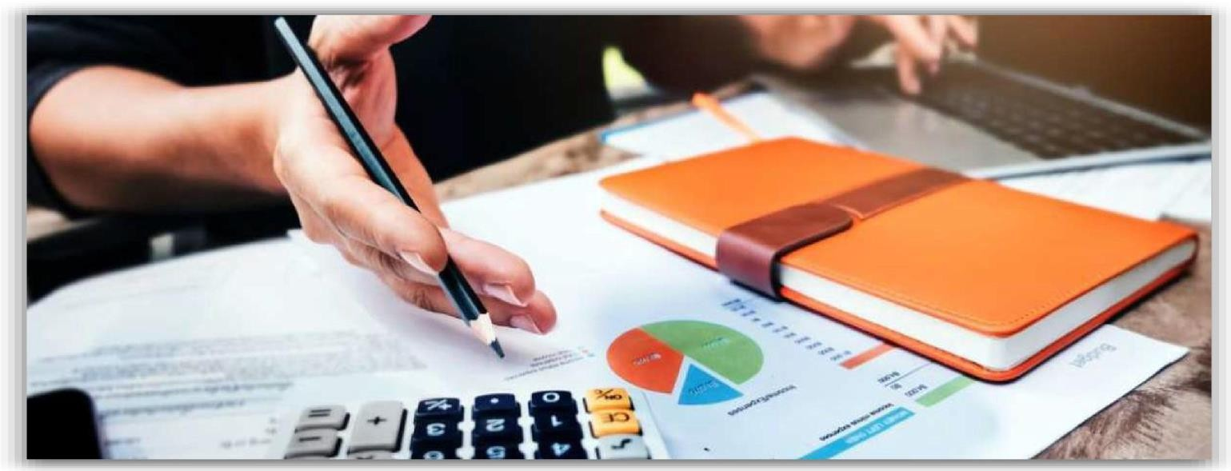





**Taxation**







**Corporate Laws**







**Consultancy**









**9873549220, 9818011067, 9417012319**

[**www.bhatiabhola.com**](http://www.bhatiabhola.com/) **mail@bhatiabhola2025@gmail.com**